Black Jack / 21 with Vision Sensor
Créée par Florian Meiner, dernière mise à jour le 29.01.2026 1 min de lecture

- Gamification 🎮
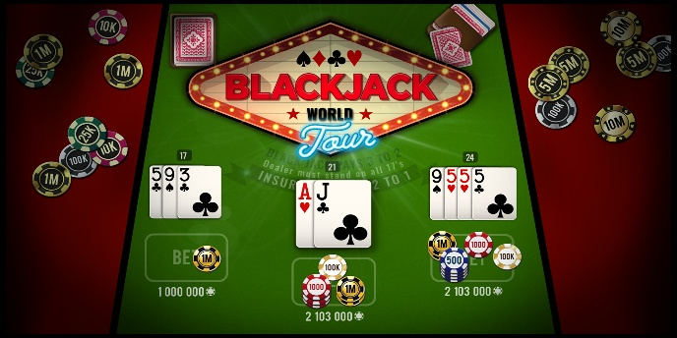
Presentation
What problem needs to be solved?
Playing cards shall be detected and automatically summed up to enable a Black Jack game with visual feedback. The system shall indicate when the value of 21 is exceeded.
Project ideas:
- Reliable recognition of card values
- Automatic calculation of the current hand value
- Dashboard for visualization and/or signal lamp for binary feedback
- Calculation of probability of exceeding the value of 21 with the next draw
- Multiplayer
Which devices and/or equipment do you need to realize the use case?
- Inspector
- Cables
- Playing cards
- Signal lamp

